Visual of Your Event.

EXHIBITOR'S GUIDE
All the informations and advices to get the best out of exhibiting at the show

Dear exhibitor, Welcome!
We are pleased to welcome you to our EVERTIQ expo at the Congress and Exhibition Center (CEC) in Mandelieu, on 8 February, 2024.
You will find in this exhibitor’s guide all the logistical and organisational details for the set-up of your stand as well as during the event and dismantling. Please read it carefully and pass it on to anyone who may be affected by these guidelines.
We thank you in advance for your understanding and cooperation.

Enjoy reading and welcome to the Congress and Exhibition Center!

The Organising Team

Exhibitor's Charter

- Not to assign, sub-let, exchange for payment or free of charge all or part of the space allocated to me.
- Not to present products other than those indicated in my application and not to exhibit illicit products or products originating from illicit activities.
- Not to encroach on the aisles with POS or merchandise.
- Present a clean stand throughout the duration of the event.
- Not remove my products nor dismantle my stand before the end of the event.
- Be present on my stand during the event’s opening hours.
- Not to smoke at my stand or inside the building.
- Not to “solicit” visitors in the aisles, respect good commercial practices towards neighbouring stands and competitors.
- Inform visitors of the prices and conditions of sale according to current regulations.
- Respect and ensure that my employees respect all legislative and regulatory provisions in terms of health and safety
- Undertake to respect the provisions of employment law and apply it to my staff
- Respect the delivery and returns deadlines according to the dates communicated by the organisers
- Respect the sanitary measures in force to fight against Covid-19 (in accordance with current government directions at the time of the event).

Non-compliance with this charter will be the subject of a written statement by the organiser. The latter reserves the right to refuse the exhibitor access, and depending on the seriousness of any breach, to close the stand.

Contacts:

The Organiser – EVERTIQ AB :  Daniel MYRTENBLAD  Expo Manager  Phone:  Mobile: +46 733 888 440  daniel.myrtenblad@evertiq.com | Logistics contact at the CEC:  Charlotte JAQUEMET  Phone: 00 33 (0)4 93 93 64 75  Mobile: 00 33 (0)7 60 19 93 13  c.jaquemet@mandelieu.com
COVID Advisor:
Odile DELANNOY
Phone: 00 33 (0)4 92 97 48 32
Mobile: 00 33 (0)6 20 58 75 60
o.delannoy@mandelieu.com

ADDRESS AND DELIVERIES:
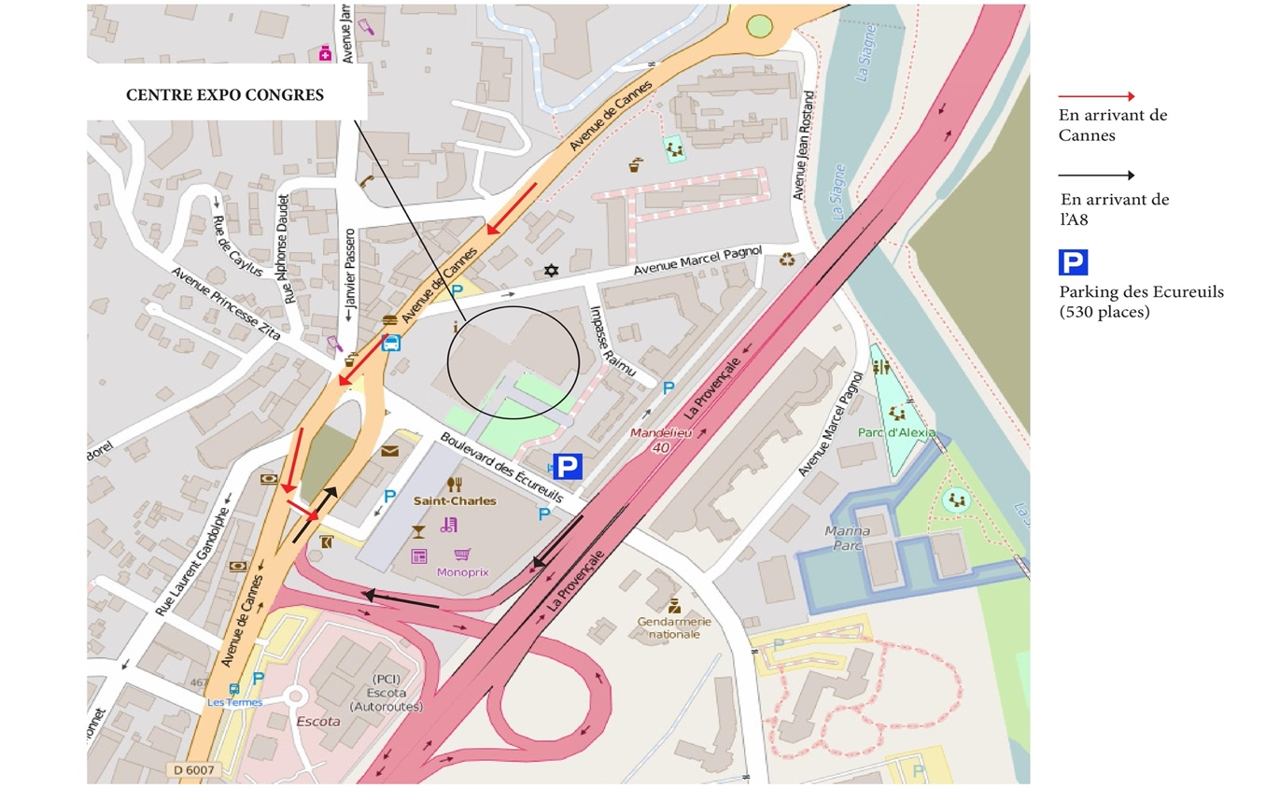

ACCESS TO THE CENTRE EXPO CONGRES (CEC) / Congress and Exhibition Center.

ADDRESS TO SEND TO THE PARTICIPANTS ON YOUR INVITATIONS (Main entrance):
CENTRE EXPO CONGRES
836, Boulevard des Ecureuils
06210 Mandelieu-La Napoule

DELIVERY ADDRESS:
CENTRE EXPO CONGRES
60, Avenue Marcel Pagnol
06210 Mandelieu-La Napoule
(at the rear of the building)

Clearly marked on each package must be :
EVERTIQ EXPO
[NAME OF RESPONSIBLE PERSON ON SITE]
[COMPANY NAME]
[PHONE NUMBER OF PERSON IN CHARGE ON SITE]
[STAND NAME]

NB: The transport of packages to the stand and from the stand to the collection area is the responsibility of the exhibitor.

HANDLING:
Exhibitors/Transporters/stands must have their own equipment to unload their vehicles/trucks with tailgate.

DELIVERY/PICKUP TIMES:

Deliveries:
*Tuesday February 6 from 9 a.m. to 4 p.m. (strictly no later than 4pm)
*Wednesday February 7 from 9 a.m. to 6 p.m. (strictly no later than 6pm)

Returns:
*Thursday February 8 from 4 to 6pm
*Friday February 9 from 9am to 12pm
Boxes must be removed no later than Friday February 9 before 12pm.

The CEC can not be held responsible in the event of loss or damage to the packages delivered or those not collected after the event. Any package, box or parcel remaining beyond 48 hours will not be kept by the CEC.

Important :
For any delivery or collection of packages by transport companies, the exhibitor is solely responsible for the package. The package cannot be delivered before the dates indicated above and must be picked up no later than Friday, February 9 between 9 a.m. and 12p.m.

PARKING
During set-up and dismantling, exhibitors are allowed to unload from the technical car park of the CEC : 60, avenue Marcel Pagnol, 06210 Mandelieu, at the rear of the building .
A security guard will be present to manage parking. Exhibitors are asked to follow the instructions given to them by this agent, in particular to exit the car park once unloading has been completed.
During the congress, exhibitors will be able to park their car in the Ecureuils public car park (802, bd des écureuils, 06210 Mandelieu) or in the "Place de France" public car park located opposite the CEC. All car parks in the municipality are free, and some require a parking disc.
Semi-trailers will not be allowed to park in the technical parking area of the exhibition centre during the event or in the surrounding public car parks.
During the set-up day, they will have to unload quickly their materiel and leave and come back for dismantling to reload their truck.

HANDLING:
Exhibitors/Transporters/Stands constructors must have their own equipment to unload their vehicles/trucks.
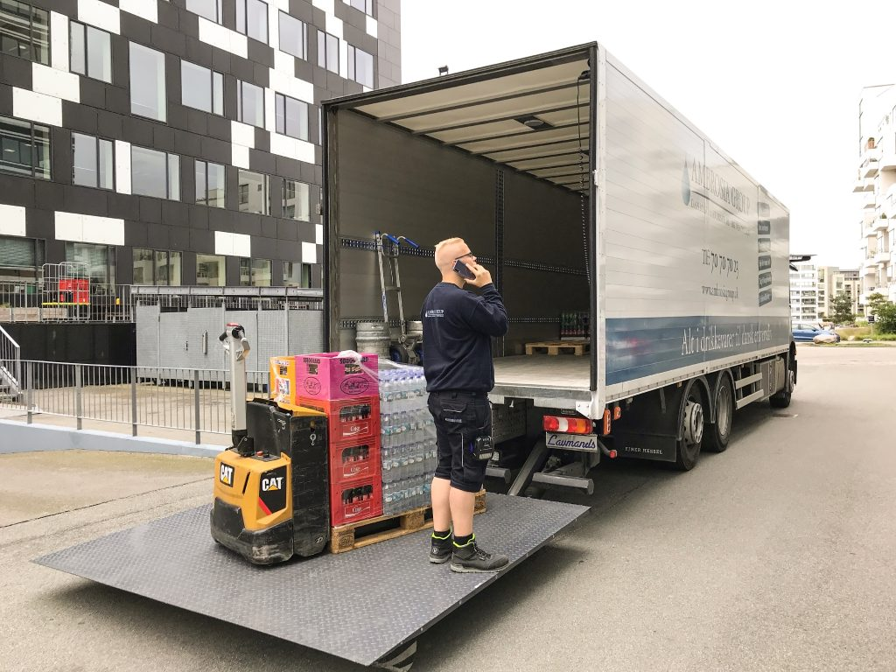
Truck with tailgate.

LIFTING EQUIPMENT / WORK AT HEIGHT:
All lifting equipment, such as forklift must be provided by the stand constructors/exhibitors and must be electrically operated. The electric forklift has to be used by trained and authorised staff with the driving forklift license and the driving authorisation from the company responsible of the stand.

All platform equipment must be provided by the stand constructors/exhibitors and must be electrically operated.The equipment has to be used by trained and authorised staff with the driving license and the driving authorisation from the company responsible of the stand.

Please inform the venue that you will be using this type of equipment. Contact : Charlotte Jaquemet : c.jaquemet@mandelieu.com

Exhibition access (from technical park) : 3.00m high / 3.60 wide.
No vehicles/trucks in the access and exhibition area.
No hanging from the ceiling.
Maximum ceiling height (exhibition area) : 4.80m.
All booth plan must be sent to the safety/fire officer one month before the event, together with the fire resistance certificates of the materials. (European certificate).
Boot plan must be validated by the safety/fire officer.
Stand constructors have to provide a certificate of good assembly of the stands.
SAFETY OFFICER 'S CONTACT : Ms Christine Renaudo : contact@resolution06.fr
In copy of your e-mail : Ms Charlotte Jaquemet : c.jaquemet@mandelieu.com

EMPTY PACKAGING:
The CEC does not have storage space to store empty boxes or pallets during the event. They must therefore be removed immediately after installation and, if necessary, brought back for dismantling.
The removal of the remaining packages (boxes, cartons, etc.), posters and other remaining material is the responsibility of the exhibitor. All this material will automatically be discarded if the exhibitor does not leave at the end of the event.

NO STORAGE ROOM AT THE CONGRESS AND EXHIBITION CENTER.

DATES TO REMEMBER:
 | Tuesday  February 6 | Wednesday  February 7 | Thursday  February 8 | Friday  February 9
Deliveries | 9am-4pm | 9am-6pm
Exhibitor set-up |  | 3pm to 6:30pm
Exhibitors can access their stand |  | 3pm to 6:30pm | 8am-6pm
Opening of the event to the participants |  |  | 9am – 4pm
Dismantling exhibitors |  |  | 4pm - 6pm
Returns packages |  |  | 4pm -6pm | 9am- 12pm

CLEANING
The CEC only pays for the cleaning of the public areas before the opening of the event. It will also take care of the maintenance of the public areas during the event: aisles, corridors, toilets...
Stand cleaning is with extra cost. Please book this service before January 8 to c.jaquemet@mandelieu.com

CONDITION OF VENUE AND EQUIPMENT, DAMAGE
Exhibitors accept furniture and equipment as provided to them and record their general condition and proper functioning. They must return them in the same conditions and state as when they received them, according to the following recommendations: it is strictly forbidden to fix or hang any furniture on tables, walls, pillars or stands.
If CEC material (provided or paid for) or equipment disappears or is damaged, it must be replaced or repaired by the exhibitor.
Exhibitors will be financially responsible for any damage they may cause to the floors, so they must take all necessary precautions to ensure the protection of the floors in case of risk.

Your pitch must be returned to its original state. All rubbish (carpet, adhesive, garbage bags, etc.) must be removed. Damage noted during the dismantling of the stands will be invoiced to you.

DISPUTES
These regulations are subject to French law. Only the Court of Justice of Grasse will be competent in the event of a dispute not resolved by mutual agreement.

SECURITY
Private surveillance of the stands can be ordered by each exhibitor, at their own expense.
The CEC cannot be held responsible for any loss, damage or theft of goods occurring on exhibitors' stands.
The CEC is not guarded at night but it is equipped with alarms.
The CEC reserves the right to refuse any person whose behaviour or dress would be considered incompatible with its image or who refuses to comply with safety rules.

ANIMALS
Animals are not allowed in the exhibition spaces. no exceptions will be accepted

REGULATED ACTIVITIES
The following activities are prohibited without the prior written consent of the CEC.
- any photograph, sound recording, film, total or partial reproduction of documents without the permission of the CEC.
- the projection of any film or other visual document without the necessary permissions.
- the use by exhibitors of their own equipment for:
* Technical services: audiovisual, electricity and telephone, etc.
* cleaning of areas
* Security services

RIGHT OF WITHDRAWAL:
Exhibitors who sell products or services within the framework of a trade fair,
exhibition or commercial event must inform consumers that they do not have the right of withdrawal. This information must be displayed, visible to consumers, on a panel of at least A3 format, comprising a text printed in a minimum font size of 90, with the following sentence: "The consumer does not have the right of withdrawal for any purchase made in this fair".

DISPLAY AND ACCESS TO FIRE SAFETY EQUIPMENT
The layout of the stands must not hide the safety signs indicating the location of the exits and emergency exits.
Emergency and firefighting equipment should not be hidden or obstructed.
Any exhibitor whose activity or location does not meet this obligation will be compelled to rearrange their space to comply.

ELECTRICAL EQUIPMENT ON THE STANDS
All electrical equipment in the stand must be installed by professionals.
The exhibitor is responsible for the electrical equipment of the stand as well as the box provided.
The exhibitor must:
- bring adapters
- check that all equipment is in compliance with European safety laws

FORBIDDEN
- Any modification of the technical characteristics of the electrical box
- Cables including wires with a cross-section of less than 1.5 mm
- Uninsulated cables
- Unprotected electrical connections through the enclosure
- Multiple bipolar sockets and connections
- Batteries and rechargeable lamps that do not comply with the NFC 15 150 standard.

MANDATORY
- Permanent access to electrical boxes for CEC technicians .
- Switch off all electrical elements during closing periods if they do not need to be constantly “ON”.
- Class 1 equipment must have a ground connection.
- Lighting containing halogen lamps must be at a minimum height of
- 2.4m and firmly fixed
- Removal of all flammable material immediately after use
- Combustible materials
- Any storage of this type of material is strictly prohibited in the exhibition spaces, in the stands, in the rear spaces...

- The use of flammable liquids is prohibited.

- Protection of the public Exhibitors are fully responsible for all demonstrations carried out.

Machines with moving parts, hot surfaces or any other danger to the public must comply with all safety standards and the CEC safety service must be notified before use. All dangerous parts must be out of reach of the public.

THE SAFETY COMMITTEE
The decisions taken by the administrative authorities following the recommendations of the safety committee may go as far as the closure of a stand and are immediately applicable.

The CEC cannot be held responsible if authorities decide to close a stand.

SMOKING IS PROHIBITED

INSURANCE

Exhibitors must take out civil liability insurance to cover the financial consequences of bodily, material and immaterial damage caused to others during their participation in the event.

WASTE COLLECTION AND SORTING

Specific equipment and resources are available to you:
- A Sorting Ambassador will be present at important times of the event, at the beginning and end of the day to advise you and help you sort your waste.
A Container Park also includes OM containers and recyclable packaging:
  - a location on the ground to collect your boxes (please open and fold them before putting them there)
  - a container for glass bottles
  - a container for paper
We will also be able to collect batteries, wooden pallets separately… contact the Sorting Ambassador who will tell you the procedure to follow

Every evening, clear your day's waste to the specific containers.
Your contribution is essential so that we all respect the environment, we are counting on you!

GUIDE "Here, We Sort"
This guide aims to involve all users of the Centre Expo Congrès in our sustainable development approach by encouraging them to use the systems put in place to promote the selective collection of waste. Depending on the spaces you occupy within the Center Expo Congrès, you will encounter different models of bins and containers for sorting waste.
Sustainable Development Policy
CEC management is committed to implementing, evaluating and improving its responsible management system in accordance with the principles of sustainable development. Management undertakes to provide the necessary resources and to act in compliance with legal and other requirements which apply to it. In order to promote our sustainable development policy in complete transparency, the management and the CEC team are committed to obtaining and maintaining the ISO 20121 international certification, which guarantees our responsible management system.
Centre Expo Congrès Equipment
On the premises of the CEC, single and double flow bins are in place, according to the needs of events, which allow the differentiated collection of recyclable packaging and household waste. In the technical car park of the building there is a container park, where a container is also available to collect glass.
Recyclable Packaging CONTAINER
Paper, newspapers, magazines, cans, plastic, cardboard, aluminum, steel and cardboard packaging and bottles. Excluded: plastic packaging wrap, and glass bottles.
Household Waste Container
Household waste, i.e. anything that cannot be recycled, excluding bulky and/or hazardous waste.
Glass Container
Glass bottles and jars. Excluded: glass from mirrors and crockery and light bulbs.
Other Collections at the CEC: Recycling of Bulky Waste
By request, under the control of the CEC's technical staff, carpet scraps and wooden pallets.
In this way, we hope to contribute, at our level, to safeguarding our planet and developing good practices in terms of sustainable development.

MANDELIEU DESTINATION
OFFICE DE TOURISME ET DES CONGRES
806, avenue de Cannes
06210 MANDELIEU
Tel: +33 (0)4 93 93 64 75 – E-mail: c.jaquemet@mandelieu.com
www.mandelieu-tourisme.com

